Positive observation of the 209 Dido asteroidal occultation of March 10, 2005.

Paolo Corelli*

Abstract. Observation methods, data collection and the following processing techniques, related to the positive observation of the 209 Dido asteroidal occultation recoded from Mandi Observatory-Pagnacco, Italy on March 10th 2005 are reported. The observation has been planned within a European program managed by EAON (European Asteroidal Occultation Network) with the purpose of increasing the knowledge of the shape of these objects as well as of their orbits. In some lucky cases (not in this) it has been possibile to detect a minor object orbiting around the main asteroid, whose existence was unknown so far.

Keywords: Astronomy, asteroids, asteroidal occultations, astronomical observation techniques.

- Introduction. One of the most profitable fields still opened to the amateur astronomers’ research is the observation of the star occultations, lunar as well as asteroidals. The first are due to the moon that, during his movement across the celestial sphere, hides the stars on the background, similarly, the second ones, happen when an asteroid, during his orbital journey, hide a star. The event, if tracked by several observers scattered along the central line whose geographic coordinates are well known, allows to compute the object shape to a better approximation than any other earthground observation even if done with the powerful telescopes. In some cases (rare) it has been possibile to record a double disappearance, due to a second minor body rounding the main asteroid. This work provides the observational method, the collected data and the following processing techniques related to the asteroidal occultation of 209 Dido, on March 10, 2005, well visible from Friuli Venezia Giulia - Italian region.

- Basic data of the phenomena. The event has been caused by asteroid 209 Dido, discovered on October 2, 1879 by Peter C.H.F. (Author of 48 discovers in total) from Clinton-USA; the object is located in the main belt area, between the Mars’s and Jupiter’s orbits. The physical parameters and orbital data are listed in table 1.

Distance at perielium | 2,95 UA (441 ML Km)
Distance at afelium | 3,35 UA (500 ML Km)
Orbit eccentricity | 0,06439
Orbit inclination | 7,18 degr.
Diameter | 149 Km
Rotation period | 8 hours
Magnitude at the event | 12,7^{m}
Table 1(font: Guide8)

The occulted star was the TYC 4940 77, astronomical data of the object are listed in tab.2 :

Right Ascention | 12h 15m 00s.04 (2000.0)
Declination | -01° 19’ 35”.7 (2000.0)
Magnitude | 7,49^{m}
Spectrum | K0
Distance | 205±38 pc (670±120 ly)
Table 2(font: Guide8)

For the observing plans, forecasts and calculation carried out by Jean Schwaenen and Steve Preston have been utilized, Jean and Steve supplied also the last minute updates. Few days before the event, at ESO La Silla site, precise astrometric positions of the asteroid have been acquired and utilized to update the maps.(fig.1)

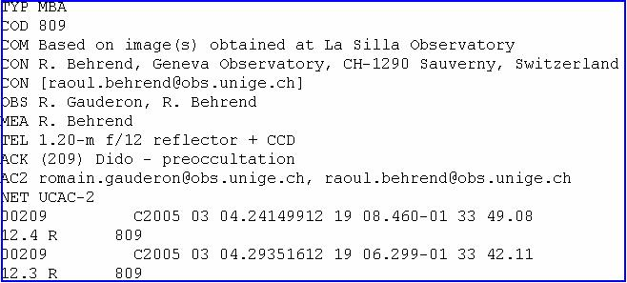
fig.1-Preliminay astrometric data collected at ESO La Silla site

On the WEB, from the EAON (and other similar sites) pages, it is possible to extract the maps for European occultations that are updated frequently, as the following (fig.2):

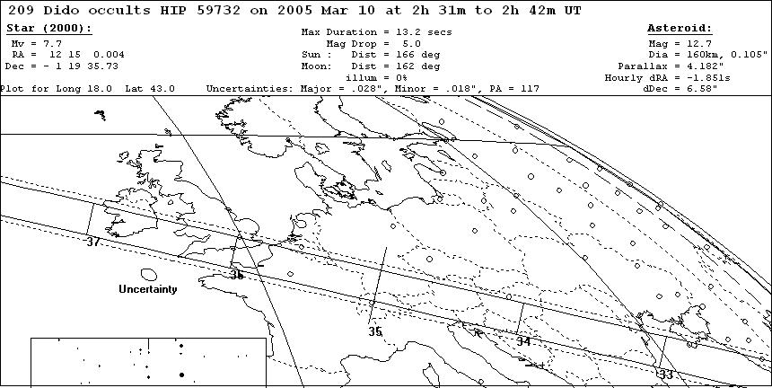
fig.2 – European map processed for 209 Dido occultation of March,10-2005

the map has been processed with WinOccult 3.1.18 and Astorb.dat dedicated software. The map supplied the following parameters: (tab.3)

Event date | March 10, 2005
Event starting time | 02h 31m U.T.
Event ending time | 02h 42m U.T.
Duration event (max) | 13,2 seconds
Magnitude loss | - 5,0 ^{m}
Table 3 (font: EAON)

From the map it was easily visible that the phenomena would be recorded even if on the marginal base, from our Region, in particular from Mandi Observatory whose geographical coordinates are the following:

- 46° 05’ 49”,96 latitude North (GPS)
- 13° 11’ 00”,90 longitude East (GPS)
- 140 m a.s.l.

As Mandi Observatory was located more than hundred Kilometers away from the center line, where the duration of the event was expected to be 13.2 seconds, the disappearance time foreseen from my location had to be within few seconds (fig.3):

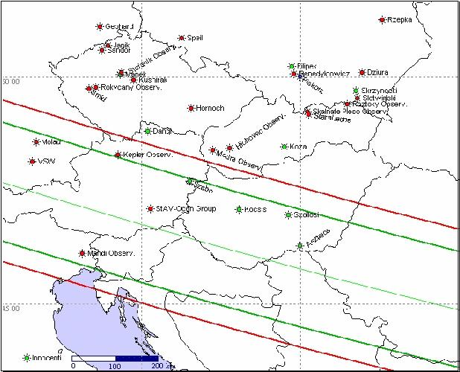
Fig.3 – map with fixed and movable observing stations scattered all over Est Europe (font: Oliver Klös)

Observations showed that this was not the case.

- The instruments set-up. To follow-up the event, a 0.20m SC reflector telescope with a focal ratio of f:10 (2000mm) has been used, with annexed a CCD electronic camera, MX916 type, 16 bit. The CCD sensor is a Sony ICX083, holding 752 x 290 px – 11.6 μm x 11.2 μm; binned x2 in this case, therefore resulting 376 x 290 px - 23.2 μm x 22.4 μm. The scale on the CCD frame was 2.4”/pixel. The main instrument, that is in fixed station inside a turning 4.0 m dome, has a home made GOTO mounting that works under LX200 protocoll and is driven by a FS2 control unit that moves the two stepper motors (R.A. – Decl.). CCD software is Astroart 3.0, while telescope mounting control software is Guide 8. A critical parameter, always present in this type of observations, is the correct clock syncronisation needed to record all the timing of the event. The accepted error should be as low as possible; in order to get a good and reliable data the error should not exceed the 0.3-0.4 seconds. To keep the internal PC clock within this value, a specific software is utilised, Dimension 4, that allows a continous check and comparison of the local clock with a standard one. In this case the Galileo Ferrari Institute atomic master clock was chosen; the program checked and corrected the error every minute.

- The observation of the event. The technique utilised to record this event is the star drift method; the star to be occulted is moved at the left side of the frame (East), then the drive motor is stopped for 60 seconds, the object shifts on the frame due to earth diurnal movement to the other side of the frame. If the occultation is positive, the stripe will not appear as a continue white line but, at some place, there will be an interruption that indicates where and when the occultation happened. Starting from the cited map, the foreseen occultation time span was calculated as follows:
- 02h 34m 00s U.T. start star drift
- 02h 35m 00s U.T. end star drift
time span can be easily deducted from the map in fig. 4:

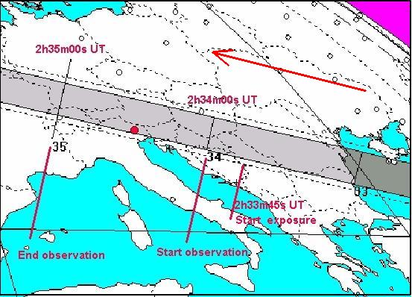
fig.4 – occultation timing deducted from the map

Before the 60s star-drift exposure, a 15s guided exposure has been activated just to avoid two operations at the same critical instant (start exposure + stop motor drive); due to this the 75s exposure started at 02h 33m 45s U.T. while the R.A. drive stepper motor has been stopped at 02h 34m 00s U.T. When the exposure ended, the frame was dark-frame subtracted to clean it from the thermic noise. At a first look the positive event was clearly evident but the duration appeared much longer than the one expected for my observing site.

- Data processing. The 60s exposure covered 352 horizontal pixels, giving a horizontal star speed of 5.87 px/second (fig.5)

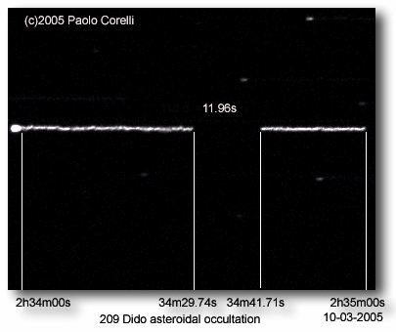
fig.5 – CCD frame of the occultation with the event timings

The occultation started after 29.74s from the beginning and ended after 41.71s, that means a duration of 11.96s much longer than expected from my observing site. The recorded data can be summarised as follows:

- 02h 34m 29.74s U.T. disappearance
- 02h 34m 41.71s U.T. reappearance
- 11.96s (+/- 0.2s) duration

fig.6 shows the profile of the star drift with the related timing:
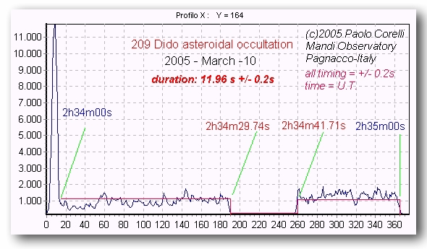
fig.6 – star drift profile with occultation timing

All the data have been sent to the European center where has been realised the sensible difference between the foreseen data and the observed data; a discussion is still under way on the correct forecast method to be applied for this kind of events. The data sent by Mandi Observatory have been utilised, together with others sent by 9 European observers to track the related chords and a first tentative shape of the 209 Dido asteroid (fig.7)

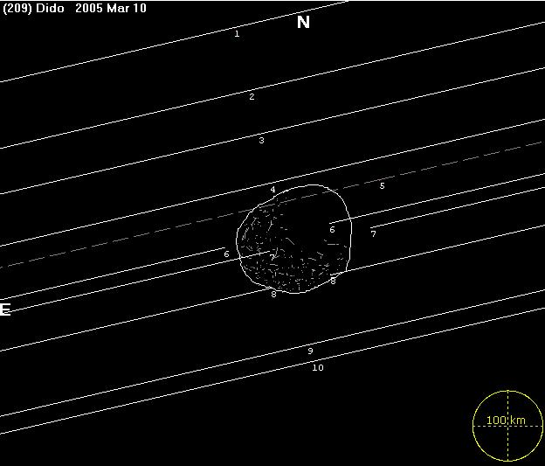
fig.7 – a first attempt to produce a 209 Dido silhouette (tentative)

- Conclusions. The sensible difference discovered after this observing section started a discussion on the forecast metodology that it is still open; in any case this remark is always valid: do the observation all the times it is possibile even if your observing location is not inside the path as the surprises are round the corner. Very important in these campaign is the number of observers, as in this case; it is desirable that, seen the low investment equipment requested to observe these events and the immediate processing of the collected data, in the future, more and more amateurs could join the present list in order to offer the best coverage possible over the entire Eropean area and contribute to improve our knowledge on the asteroids physical parameters and their orbits.

- References. All the information used in this work have been obtained from the WEB; several good sites are updated frequently; they offer also a lot of observational tips and practical advices. Here are some useful links.
- http://www.euraster.net/results/index.html
- http://www.asteroidoccultation.com/
- http://www.asteroidoccultation.com/asteroid_help.htm
- http://www.eclipsetours.com/occultationa
- http://lunar-occultations.com/iota/iotandx.htm
- http://iota.jhuapl.edu/
- http://www.aula.com/eaon/
- http://mpocc.astro.cz/2005/
- http://astrosurf.com/eaon/

8 . Bibliography

Bash, F.N. (1984). Observatory report. University of Texas at Austin. Amer. Astron. Society 16: pp 333-356
Bowell et Al.(1978). A possible satellite of Herculina (abstract). Bull.Amer.Astron.Soc. 10 :594
Bus, S.J. et Al(1995). Stellar occultation by 2060 Chiron. Icarus 123: No 2 pp 478-490
Danham, D.W. et Al.(2002). Asteroidal occultation results multiply helped by HIPPARCOS. Memorie della Società Astronomica Italiana. Vol 73 No3 pp 662-665
Dunham, D.W. and Bode, H.J.(1984). IOTA/ES News Occultation Newsletter 3:162
Dunham, D.W. (1979a). Duplicity of both (18) Melpomene and SAO 114159 discovered during occultation. Occultation newsletter 2: pp 12-16
Hubbard, W. and Van Flaudern, T.C. (1972). The occultation od Beta Scorpii by Jupiter and Io. III Astrometry Astronomical J. 77, pp 65-74
Kristensen, L. (1981). The size of (51) Nemausa. Astron. & Astroph. Suppl. Series 44: pp 375-377
Manly Peter (1994). The 20 cm Schmidt-Cassegrain Telescope.A practical observing guide. Cambridge University Press
Marsden, B.G. (1982). Occultation of BD+24522 by (690)Wratislava.IAU Circular No 3747
Marsden, B.G. (1983). Occultation of AGK3 +11 201 by (19) Fortuna. IAU Circular No 3776
Millis, R.L. et Al. (1985). The occultation of AG +29 398 by (93)Minerva. Icarus 61: pp 124-131
Ogasawara, M. (1981). Observer’s guide. Tenmon To Kisho 73 : 104
Overbeek, M.D. (1983). Planetary occultation section (Report) Mont. Not. Astron. Soc. Southern Africa 42: pp 28-29
Sheffer, Y. (1979). More on Juno. Occultation Newsletter 2: p 27
Taylor, G.E., and Dunham, D.W. (1978). The size of minor planet (6) Hebe. Icarus 34: pp 89-92
Wasserman, L.H. et Al. (1979). The diameter of Pallas from its occultation of SAO 85009. Astronomical Journal 84: pp 259-268

* Mandi Observatory-Pagnacco, Italy

